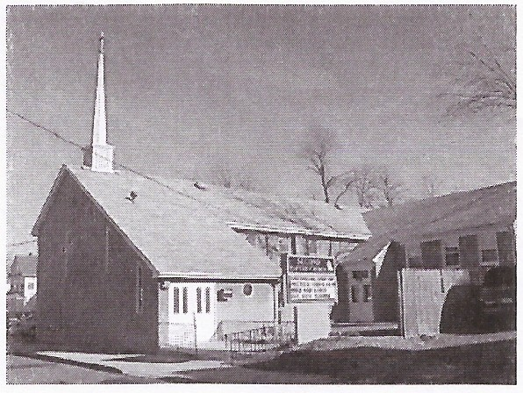
SENIOR PASTOR
Rev. Dr. Michael A. Lester, Sr.

CHAIRMAN- Deacon Ministry
Deacon John Cook

SECOND BAPTIST CHURCH
45 Orchard Street
Matawan, NJ 07747
Church - 732-566-9135
Email:sbcmatawan@yahoo.com
CHAIRPERSON - Trustee Ministry

CHURCH CLERK/SECRETARY
Sis. Sharon Myers

New Discipleship Information Form

NAME: __________________________________________________________________________

ADDRESS: ______________________________________________________________________

CITY: __________________________________ STATE: __________ ZIP CODE: _____________

EMAIL ADDRESS: ___________________________________________________________________

EMERGENCY CONTACT: ______________________________________________________________

FORMER HOUSE OF WORSHIP: ________________________________________________________

YEAR OF BAPTISM: ______________________

By Way of Discipleship (Check One)
l.) Baptism:
2.) Christian Experience:

3.) Letter:

4.) Reinstatement:

5.) Watch care:

